# **Checklist Items 4-5 – Static Performance Test**

## **Check V$SYSSTAT**

SQL> SET ECHO ON;

SQL>

SQL> SET SERVEROUTPUT ON;

SQL>

SQL> /*---------------------------------------------------*/

SQL> /* Part 2 Checklist Items 4-5 */

SQL> /*---------------------------------------------------*/

SQL>

SQL> /*Check v$sysstat*/

SQL> DESC v$sysstat;

Name Null? Type

---------- ----- ------------

STATISTIC# NUMBER

NAME VARCHAR2(64)

CLASS NUMBER

VALUE NUMBER

STAT_ID NUMBER

CON_ID NUMBER

SQL>

SQL> SELECT name,value FROM v$sysstat WHERE name like 'physical%';

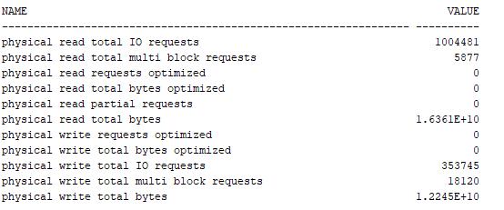

SQL>

SQL> SELECT name,value FROM v$sysstat WHERE name like '%cache%';

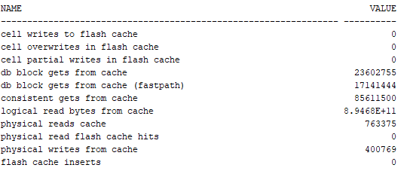

SQL>

SQL> SELECT name,value FROM v$sysstat;

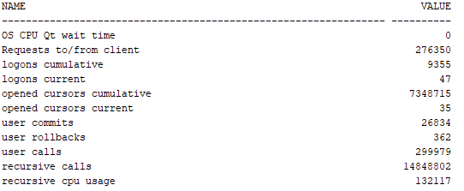

## **Read Load**

SQL>

SQL>

SQL> /*Run five stats, then read load, then five stats again*/

SQL> /*Check Stats*/

SQL> SELECT name, value FROM V$sysstat where name IN ('CPU used when call started', 'physical reads', 'physical writes', 'concurrency wait time', 'Requests to/from client');

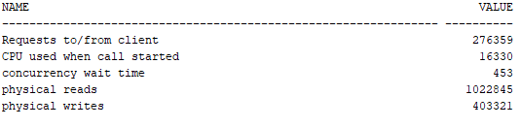

SQL> /*Read Load - Same Command is ran 200 times to generate a intense load that takes at least 60 seconds.*/

SQL>

SQL> SELECT z1.zipcode,

2 (SELECT count(c1.zipcode) FROM DataDesignLeadUser.CUSTOMER c1 WHERE c1.zipcode = z1.zipcode AND c1.zipcode =

3 (SELECT c0.zipcode FROM DataDesignLeadUser.CUSTOMER c0 WHERE c0.customerid = c1.customerid)) cust_zip_usage,

4 (SELECT count(e0.zipcode) FROM DataDesignLeadUser.EMPLOYEE e0 WHERE e0.zipcode = z1.zipcode AND e0.zipcode =

5 (SELECT e2.zipcode FROM DataDesignLeadUser.EMPLOYEE e2 WHERE e2.sales_emp_ssn = e0.sales_emp_ssn)) emp_zip_usage,

6 (SELECT avg(p1.payment_amount) FROM DataDesignLeadUser.PAYMENT p1 WHERE p1.orderid = o1.orderid) payment_avg,

7 (SELECT sum(p0.prod_unit_price) FROM DataDesignLeadUser.PRODUCT p0 WHERE p0.productid = pr1.productid) unit_cost_sum,

8 (SELECT count(z0.zipcode) FROM DataDesignLeadUser.ZIP z0 WHERE z0.zipcode = z1.zipcode) random_zip,

9 (SELECT count(o0.orderid) FROM DataDesignLeadUser.ORDERS o0 WHERE o0.orderid = o1.orderid) order_count,

10 (SELECT count(s0.storeid) FROM DataDesignLeadUser.STORES s0 WHERE s0.storeid = s1.storeid) store_count,

11 (SELECT count(r0.regionid) FROM DataDesignLeadUser.REGION r0 WHERE r0.regionid = r1.regionid) region_count,

12 (SELECT count(oi0.orderid) FROM DataDesignLeadUser.ORDER_ITEM oi0 WHERE oi0.orderid = o1.orderid) order_item_count,

13 (SELECT count(pc0.prodcatid) FROM DataDesignLeadUser.PRODUCT_CAT pc0 WHERE pc0.prodcatid = pc1.prodcatid) prod_cat_count

14 FROM DataDesignLeadUser.ZIP z1

15 FULL JOIN DataDesignLeadUser.CUSTOMER c2 ON c2.zipcode = z1.zipcode

16 FULL JOIN DataDesignLeadUser.ORDERS o1 ON o1.customerid = c2.customerid

17 FULL JOIN DataDesignLeadUser.PAYMENT p2 ON p2.orderid = o1.orderid

18 FULL JOIN DataDesignLeadUser.ORDER_ITEM oi1 ON oi1.orderid = o1.orderid

19 FULL JOIN DataDesignLeadUser.PRODUCT pr1 ON pr1.productid = oi1.productid

20 FULL JOIN DataDesignLeadUser.PRODUCT_CAT pc1 ON pc1.prodcatid = pr1.prodcatid

21 FULL JOIN DataDesignLeadUser.EMPLOYEE e1 ON e1.sales_emp_ssn = o1.sales_emp_ssn

22 FULL JOIN DataDesignLeadUser.STORES s1 ON s1.storeid = e1.storeid

23 FULL JOIN DataDesignLeadUser.REGION r1 ON r1.regionid = s1.regionid

24 ORDER BY cust_zip_usage DESC;

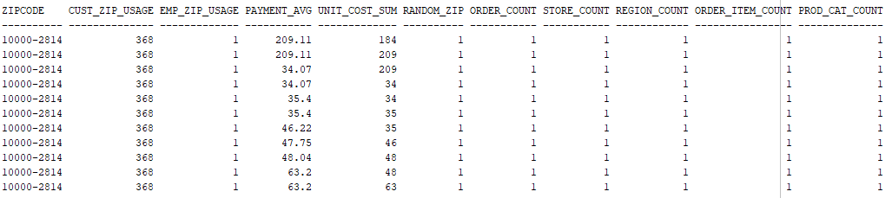

SQL> /*Check Stats*/

SQL> SELECT name, value FROM V$sysstat where name IN ('CPU used when call started', 'physical reads', 'physical writes', 'concurrency wait time', 'Requests to/from client');

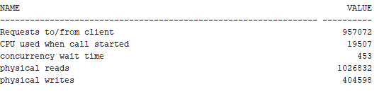

SQL> /*Flush shared pool before write load*/

SQL> ALTER SYSTEM flush shared_pool;

System FLUSH altered.

## **Write Load**

SQL> /*Run five stats, then write load, then five stats again*/

SQL>

SQL> /*Check Stats*/

SQL> SELECT name, value FROM V$sysstat where name IN ('CPU used when call started', 'physical reads', 'physical writes', 'concurrency wait time', 'Requests to/from client');

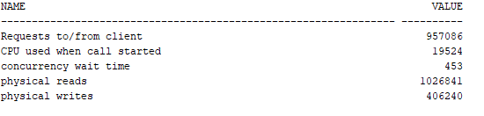

SQL>

SQL> /*Drop/Create region backup table*/

SQL> DROP TABLE regionbackup;

Error starting at line : 4,646 in command -

DROP TABLE regionbackup

Error report -

ORA-00942: table or view does not exist

00942. 00000 - "table or view does not exist"

*Cause:

*Action:

SQL>

SQL> CREATE TABLE regionbackup (

2 regionid NUMBER(10) NOT NULL,

3 regionname VARCHAR(25),

4 description VARCHAR(150),

5 CONSTRAINT pk_region PRIMARY KEY ( regionid )

6 USING INDEX TABLESPACE user_indx1

7 STORAGE ( INITIAL 50 K NEXT 10 K )

8 )

9 PCTFREE 5 PCTUSED 90 TABLESPACE user_data1

10 STORAGE ( INITIAL 192 k NEXT 20 k MAXEXTENTS UNLIMITED PCTINCREASE 0 );

Table REGIONBACKUP created.

SQL>

SQL> /*Insert current data*/

SQL> INSERT INTO regionbackup SELECT * FROM DataDesignLeadUser.region;

1,000 rows inserted.

SQL>

SQL>

SQL> /*Create loop to insert from 1,001 to 1,000,000 additional rows*/

SQL> BEGIN

2 FOR v_LoopCounter IN 1001..1000000 LOOP

3 INSERT INTO REGIONBACKUP (regionid,regionname, description)

4 VALUES (v_LoopCounter, 'name', 'description');

5 END LOOP;

6 END;

7 /

PL/SQL procedure successfully completed.

SQL> /*Verify data is there*/

SQL>

SQL> SELECT * FROM REGIONBACKUP;

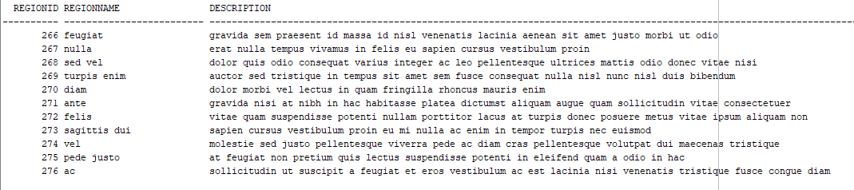

SQL>

SQL> /*Run loop to delete each record individually*/

SQL>

SQL> declare

2 i number := 1;

3 cursor s1 is SELECT rowid, r.* FROM REGIONBACKUP r;

4 begin

5 for c1 in s1 loop

6 DELETE FROM REGIONBACKUP

7 WHERE regionid = i;

8 i := i + 1;

9 end loop;

10 commit;

11 end;

12 /

PL/SQL procedure successfully completed.

SQL>

SQL> /*Verify data is Gone*/

SQL> SELECT * FROM REGIONBACKUP;

no rows selected

SQL>

SQL> /*Do it again!*/

SQL>

SQL> /*Drop/Create region backup table*/

SQL> DROP TABLE regionbackup;

Table REGIONBACKUP dropped.

SQL>

SQL> CREATE TABLE regionbackup (

2 regionid NUMBER(10) NOT NULL,

3 regionname VARCHAR(25),

4 description VARCHAR(150),

5 CONSTRAINT pk_region PRIMARY KEY ( regionid )

6 USING INDEX TABLESPACE user_indx1

7 STORAGE ( INITIAL 50 K NEXT 10 K )

8 )

9 PCTFREE 5 PCTUSED 90 TABLESPACE user_data1

10 STORAGE ( INITIAL 192 k NEXT 20 k MAXEXTENTS UNLIMITED PCTINCREASE 0 );

Table REGIONBACKUP created.

SQL>

SQL> /*Insert current data*/

SQL> INSERT INTO regionbackup SELECT * FROM DataDesignLeadUser.region;

1,000 rows inserted.

SQL>

SQL> /*Create loop to insert from 1,001 to 1,000,000 additional rows*/

SQL> BEGIN

2 FOR v_LoopCounter IN 1001..1000000 LOOP

3 INSERT INTO REGIONBACKUP (regionid,regionname, description)

4 VALUES (v_LoopCounter, 'name', 'description');

5 END LOOP;

6 END;

7 /

PL/SQL procedure successfully completed.

SQL> /*Verify data is there*/

SQL> SELECT * FROM REGIONBACKUP;

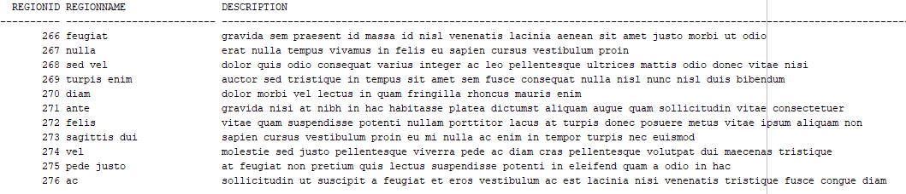

SQL>

SQL> /*Run loop to delete each record individually*/

SQL>

SQL> declare

2 i number := 1;

3 cursor s1 is SELECT rowid, r.* FROM REGIONBACKUP r;

4 begin

5 for c1 in s1 loop

6 DELETE FROM REGIONBACKUP

7 WHERE regionid = i;

8 i := i + 1;

9 end loop;

10 commit;

11 end;

12 /

PL/SQL procedure successfully completed.

SQL>

SQL> /*Verify data is Gone*/

SQL> SELECT * FROM REGIONBACKUP;

no rows selected

SQL>

SQL>

SQL> /*Check Stats*/

SQL> SELECT name, value FROM V$sysstat where name IN ('CPU used when call started', 'physical reads', 'physical writes', 'concurrency wait time', 'Requests to/from client');

